DSR Portal
User Guide

For privacy teams, zone managers and administrators
Version 1.0 · 20 August 2026

Contents
Right-click here and choose Update Field to build the contents.
If the list above is empty, click it once and press F9 to populate it.

1. About the portal
The DSR Portal receives privacy requests from the public and manages them through to a documented outcome. It replaces the previous hosted forms with an identical public experience and adds a full case-management console behind it.

1.1 What it does
- Publishes 12 public request forms across three zones: Europe (EUR), South America (SAZ) and Middle Americas (MAZ).
- Verifies the requester owns the email address before a case is created, so no unverified data is ever stored.
- Creates a case with a reference like DSR-EUR-2026-00147, starts the statutory clock and assigns it automatically.
- Tracks the case through a controlled status workflow with reminders, extensions and a mandatory outcome at closure.
- Sends templated replies from the privacy mailbox and records every message on the case.
- Keeps an append-only audit trail of every view, change and send, for regulatory inspection.

1.2 Where to find it
Surface | Address | Who uses it
Public request forms | https://68-183-91-209.sslip.io/ | Data subjects (the public)
Internal console | https://68-183-91-209.sslip.io/admin/ | Privacy team and administrators

Tip Both addresses are served over HTTPS with a certificate from Let's Encrypt that renews itself. Anyone who types the bare IP address, http://68.183.91.209/, is redirected to the secure address automatically, so bookmarks and printed links keep working.

1.3 Roles and what each can do
Every person has exactly one role. Roles are cumulative going down the table, except the auditor, which is deliberately read-only and never inherits the ability to change anything.
Role | Can do
Super administrator | Everything, plus the Settings screen: email provider and credentials, portal URLs, security limits and branding. Only a super administrator can create another one.
Administrator | All zones. Cases, forms and SLAs, templates, team, audit log. Cannot open Settings.
Zone manager | Their own zone only. Cases, that zone's forms and SLAs, templates, and their zone's team roster.
Zone agent | Their own zone's cases: work them, change status, reply, close. No configuration.
Auditor | Read-only across all zones, plus the audit log. Cannot change anything.

2. The public request experience
This is what a member of the public sees. Understanding it helps when you are answering questions about a request.

2.1 Choosing a form
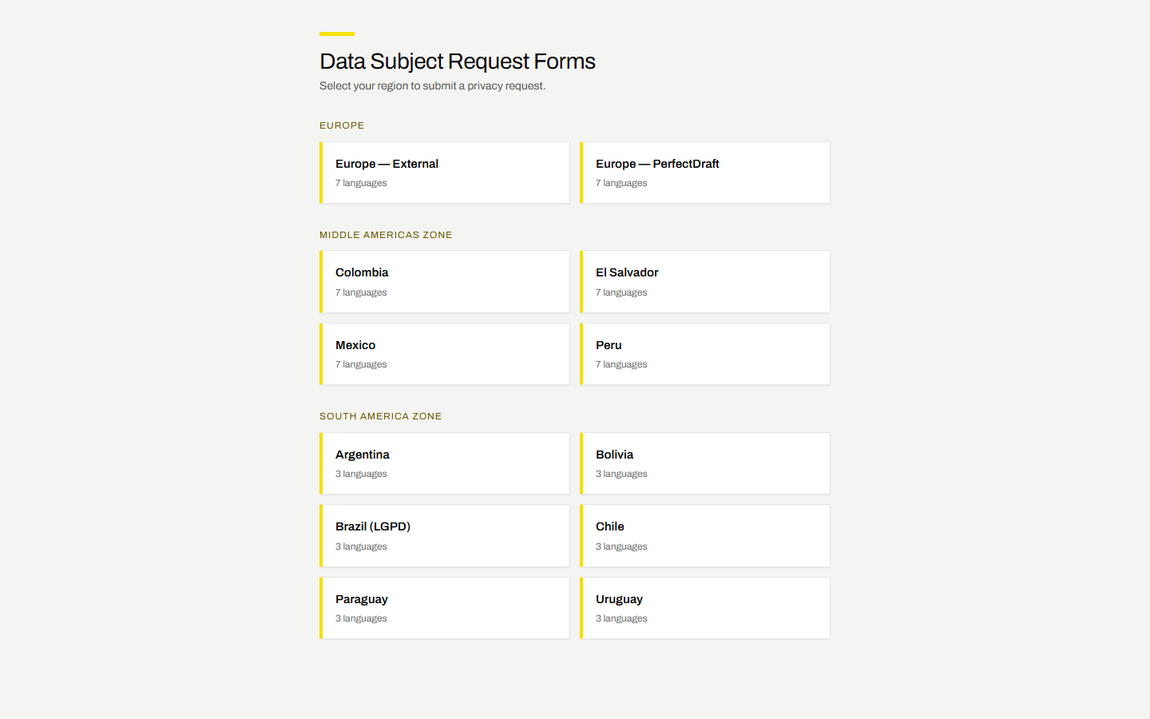
Figure 1 — the public landing page, grouped by zone
Requesters pick the form for their region. Each form carries its own fields, legal wording and languages.

2.2 Filling in the form
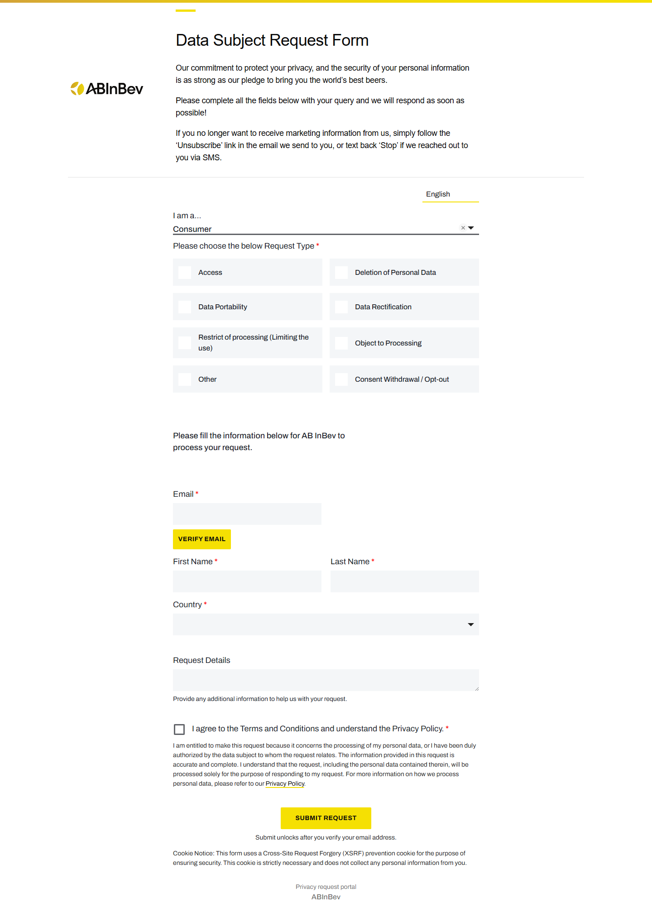
Figure 2 — the Europe request form
- The form is an exact replica of the original hosted version: same fields, wording, order and languages.
- Fields marked with a red asterisk are required.
- Some fields appear only when relevant, for example the rectification table appears once Data Rectification is ticked.
- The language selector switches all labels and legal copy.

2.3 Email verification
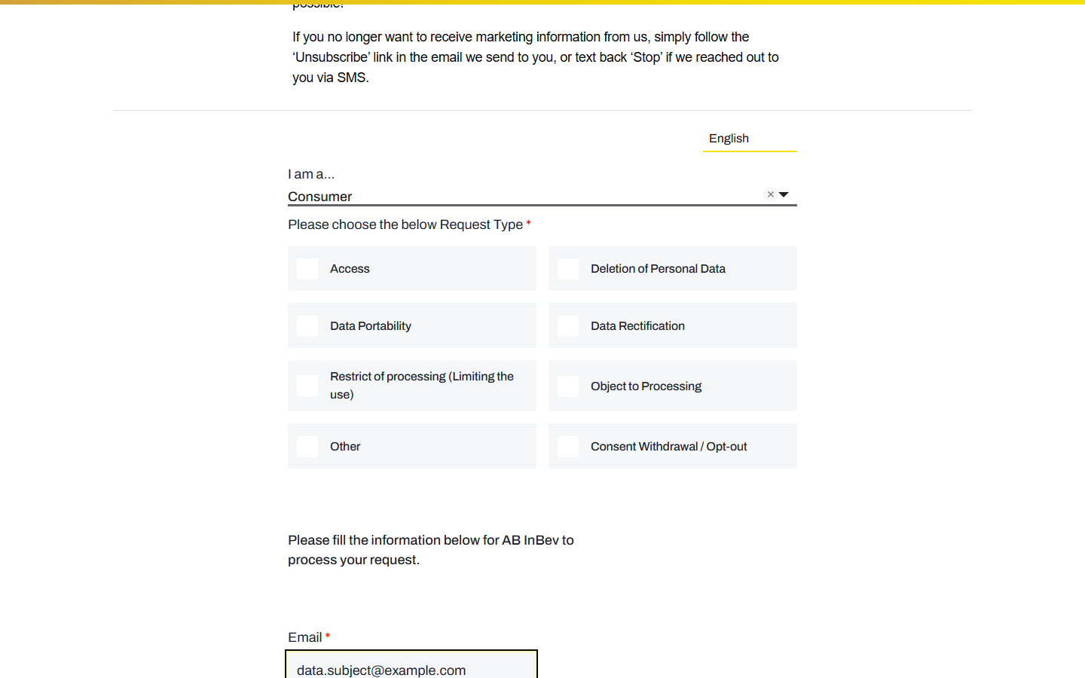
Figure 3 — the Verify email step
- The requester types their email address and presses Verify email.
- The portal emails a single-use link that expires after 15 minutes.
- Clicking the link marks that browser session verified; the page notices within a couple of seconds.
- Submit only unlocks after verification, and the server checks it again on submission.
Note Changing the email address after verifying resets the check. This is deliberate: it stops someone verifying one address and submitting under another.

2.4 What happens on submission
- The server re-validates every field. Client-side validation is treated as bypassed.
- A case is created with a reference number, and identifying fields are encrypted.
- The statutory clock starts from the moment of verified submission.
- The requester receives an acknowledgement email quoting the reference and the response date.
- The case is auto-assigned to a team member, who is emailed a direct link.

3. Signing in
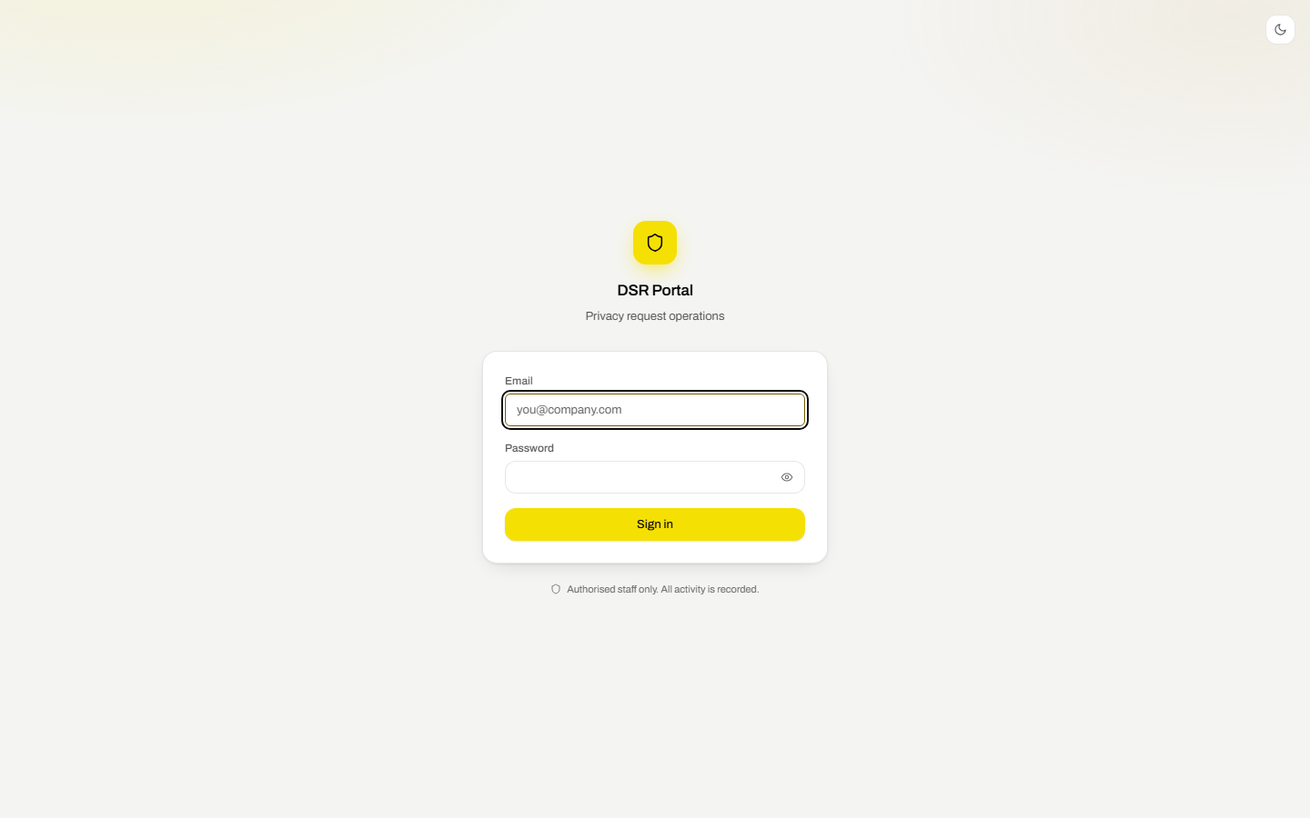
Figure 4 — the console sign-in screen
- Open the internal console address.
- Enter your work email and password. Use the eye icon to check what you typed.
- You arrive on the dashboard for your zone.
- Sessions end after 30 minutes of inactivity, and after 8 hours regardless. Both are configurable in Settings.
- After ten failed attempts from one address in an hour, further attempts are refused for the rest of that hour.
- Signing out is in the menu under your name, top right.

3.1 Getting around
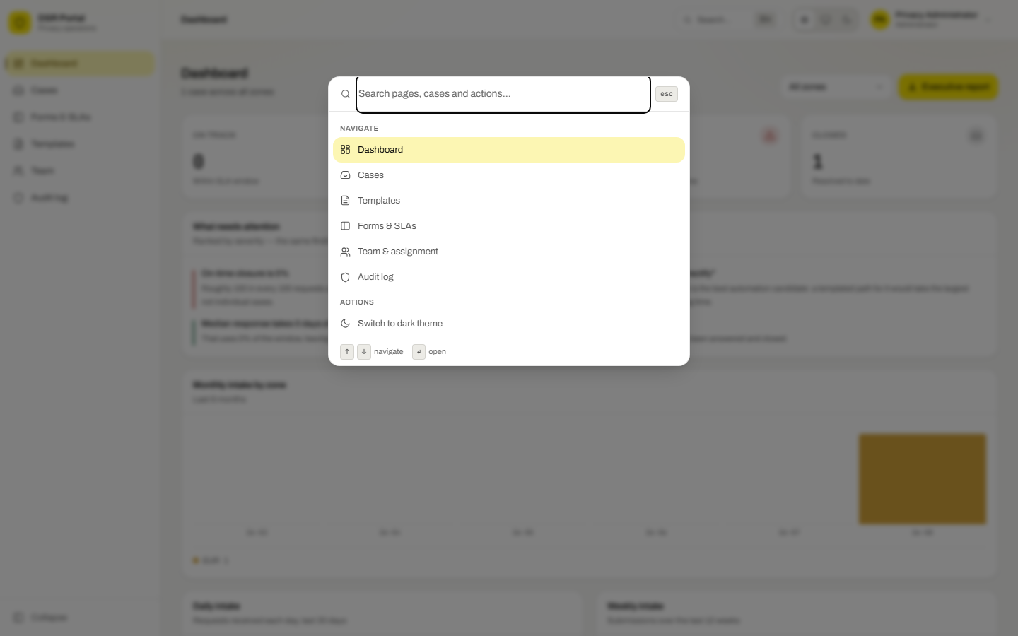
Figure 5 — the command palette
- The left sidebar holds the main sections. Use Collapse at the bottom to widen the working area.
- Press Ctrl+K (or Cmd+K) anywhere to jump to a page, switch theme, or open a recent case.
- The three icons at the top right switch between light, system and dark appearance. Your choice is remembered.

4. Dashboard
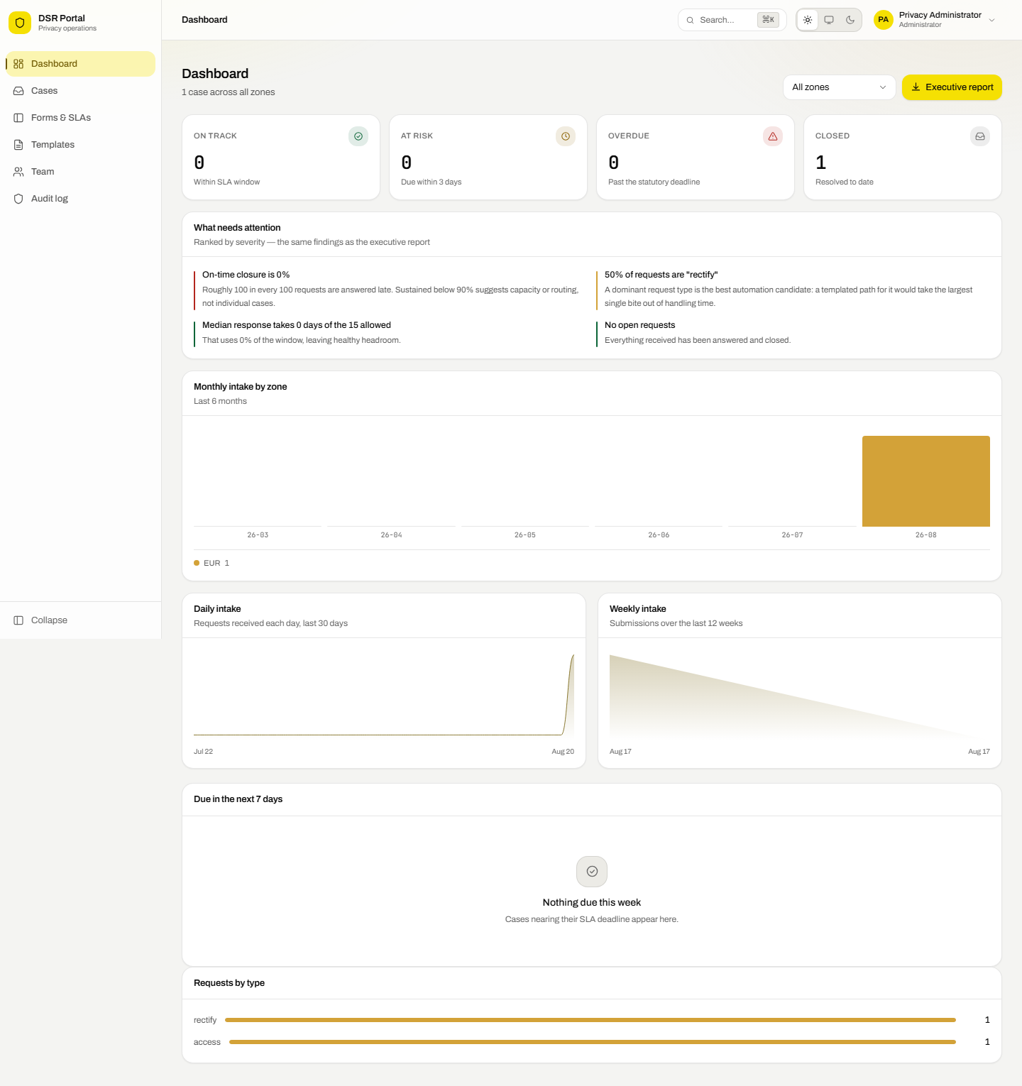
Figure 6 — the dashboard
The dashboard answers one question: is anything about to breach?
Panel | What it tells you
On track | Open cases comfortably inside their deadline.
At risk | Open cases due within three days. Work these first.
Overdue | Past the statutory deadline. Escalate these immediately.
Closed | Cases resolved to date.
Weekly intake | Submission volume over twelve weeks. Hover any point for the exact count.
Cases by status | Where the workload is sitting in the workflow.
Requests by type | Which rights are being exercised most.
Open cases per assignee | Whether work is spread evenly across the team.
Due in the next 7 days | Your working list for the week. Click any row to open the case.

Administrators and auditors can switch zones with the selector at the top right. Zone managers and agents always see their own zone.

5. Working a case

5.1 Finding cases
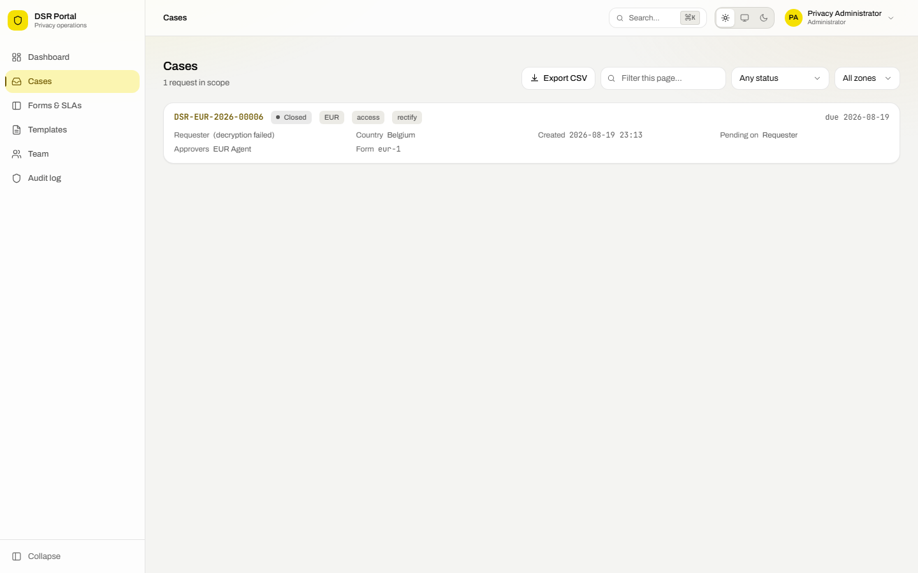
Figure 7 — the case list
- Filter by status and, if you have access to more than one, by zone.
- The search box narrows the rows already loaded, by reference, requester or request type.
- Overdue due-dates are shown in red with a warning icon.
- Click any row to open the case.

5.2 The case screen
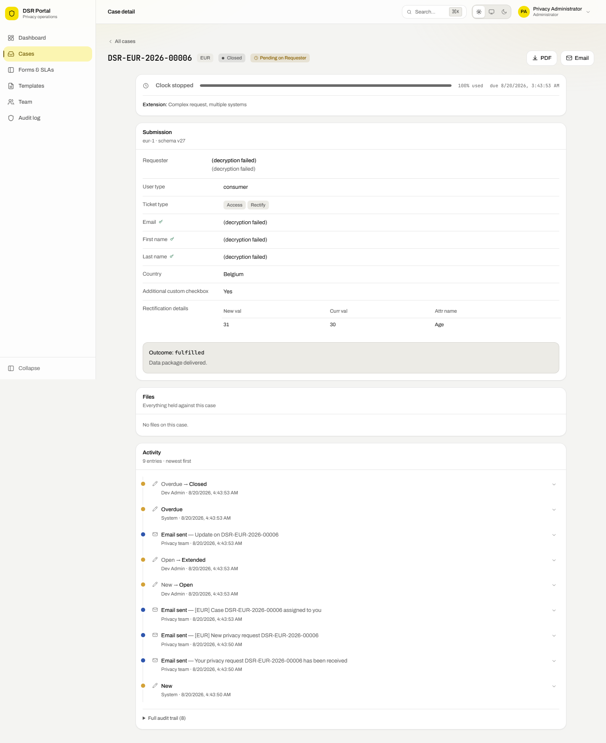
Figure 8 — a case in detail
The left panel is the submission exactly as the requester filled it in, rendered against the form version in force at the time. A key icon marks fields that are encrypted at rest.
The right column carries the SLA clock, the timeline of every status change, and the correspondence sent so far.

Changing status
Use **Status** in the action bar. The portal only offers moves that are legal from the current status, and enforces the rules that matter:
Status | Meaning and rules
New | Just submitted, not yet picked up.
Open | Being worked on.
Pending | Waiting on the requester, for example for identity evidence.
Pending Approver | Waiting on an internal approval.
Extended | Requires a written justification and a new due date. The portal reminds you to tell the requester, which GDPR Article 12(3) requires within the original month.
Overdue | Set by the system only when the clock passes the deadline. You cannot set it by hand.
Closed | Requires an outcome code and a closing note. Stops the SLA clock.

Outcome codes
- Fulfilled — everything asked for was done.
- Partially fulfilled — part was actioned; the rest was exempt or concerned other people.
- Refused — manifestly unfounded or excessive, or an exemption applied.
- Withdrawn — the requester asked to stop.
- Identity not verified — closed because identity could not be established.
- Out of scope — the data is not ours to act on.

Reassigning
**Assign** moves the case to another member of the same zone. When a case already has an owner, a reason is required and is written to the audit log.

Pausing the clock
Where the zone's policy permits it, **Pause** stops the SLA clock while you wait on the requester. Resuming pushes the due date out by exactly the paused time. Where the regime does not allow stopping the clock, the button is not offered.

Replying
**Send response** opens the composer. Pick a template, and the subject and body are filled in with the case details already substituted. Edit anything you like before sending. Every message is logged on the case and in the audit trail.

6. Response templates
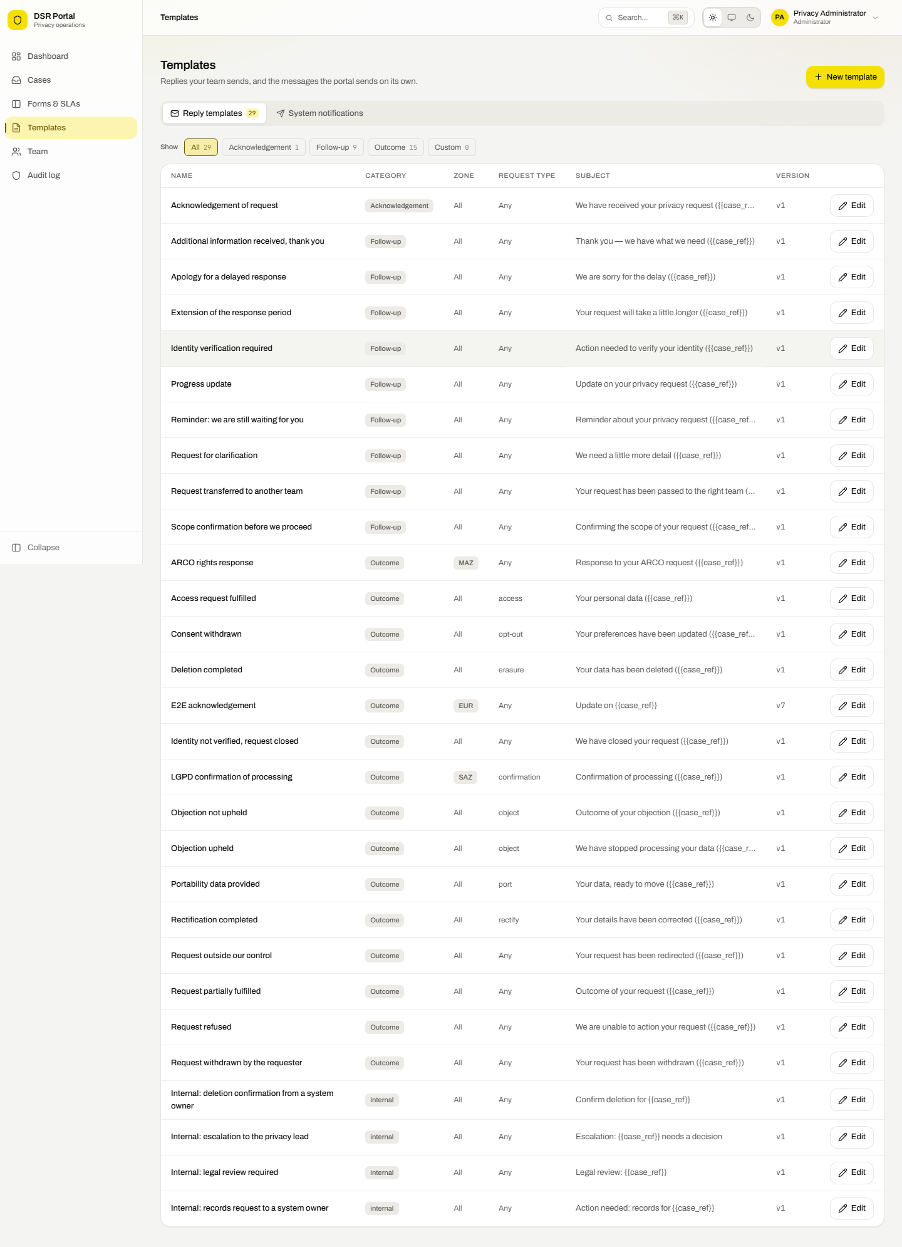
Figure 9 — the template library
The portal ships with eighteen professionally written templates covering every common outcome, including acknowledgement, identity verification, clarification, extension, each fulfilment type, refusal, withdrawal and out-of-scope, plus LGPD and ARCO variants for the South and Middle Americas zones.

6.1 Editing a template
- Open Templates and press Edit on the row you want.
- Change the name, zone, request type, subject or body.
- Press Save new version. The previous wording is kept as an earlier version.
Note Leaving Zone blank makes a template available in every zone. Leaving Request type blank makes it available for every type.

6.2 Variables
Anything in double braces is replaced when the draft is built. Click a variable chip under the body box to insert it.
Variable | Becomes
{{case_ref}} | The case reference, for example DSR-EUR-2026-00147
{{requester_name}} | The requester's name as submitted
{{requester_email}} | The verified email address
{{zone}} | EUR, SAZ or MAZ
{{request_type}} | The rights being exercised
{{submission_date}} | The date the request was verified and submitted
{{due_date}} | The current statutory deadline
{{assignee_name}} | The team member handling the case

Important The supplied wording is a professional starting point, not legal advice. Have Legal review the templates for each jurisdiction before you use them with real requesters.

7. Editing forms and SLAs
Administrators and zone managers can change the public forms and the deadlines they run on, without a developer and without a deployment.

7.1 The forms list
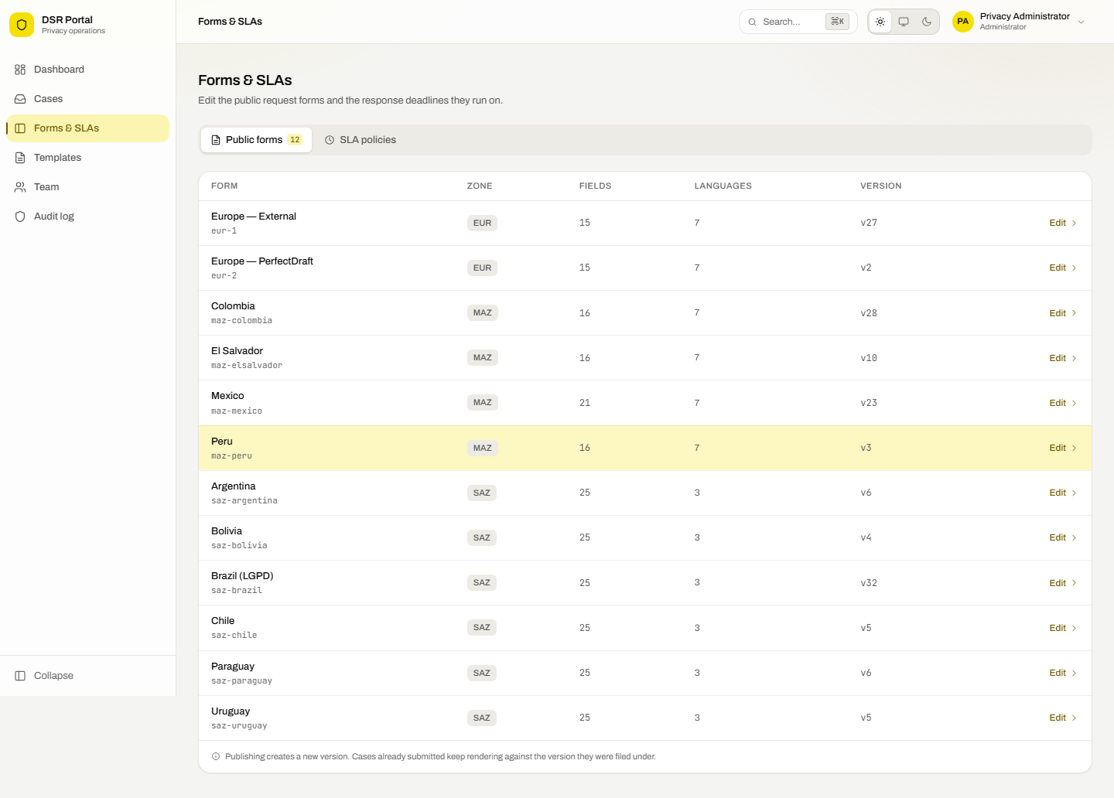
Figure 10 — forms available to edit
Each row shows the zone, how many fields the form has, how many languages it supports and which version is live. Zone managers only see their own zone.

7.2 Editing fields
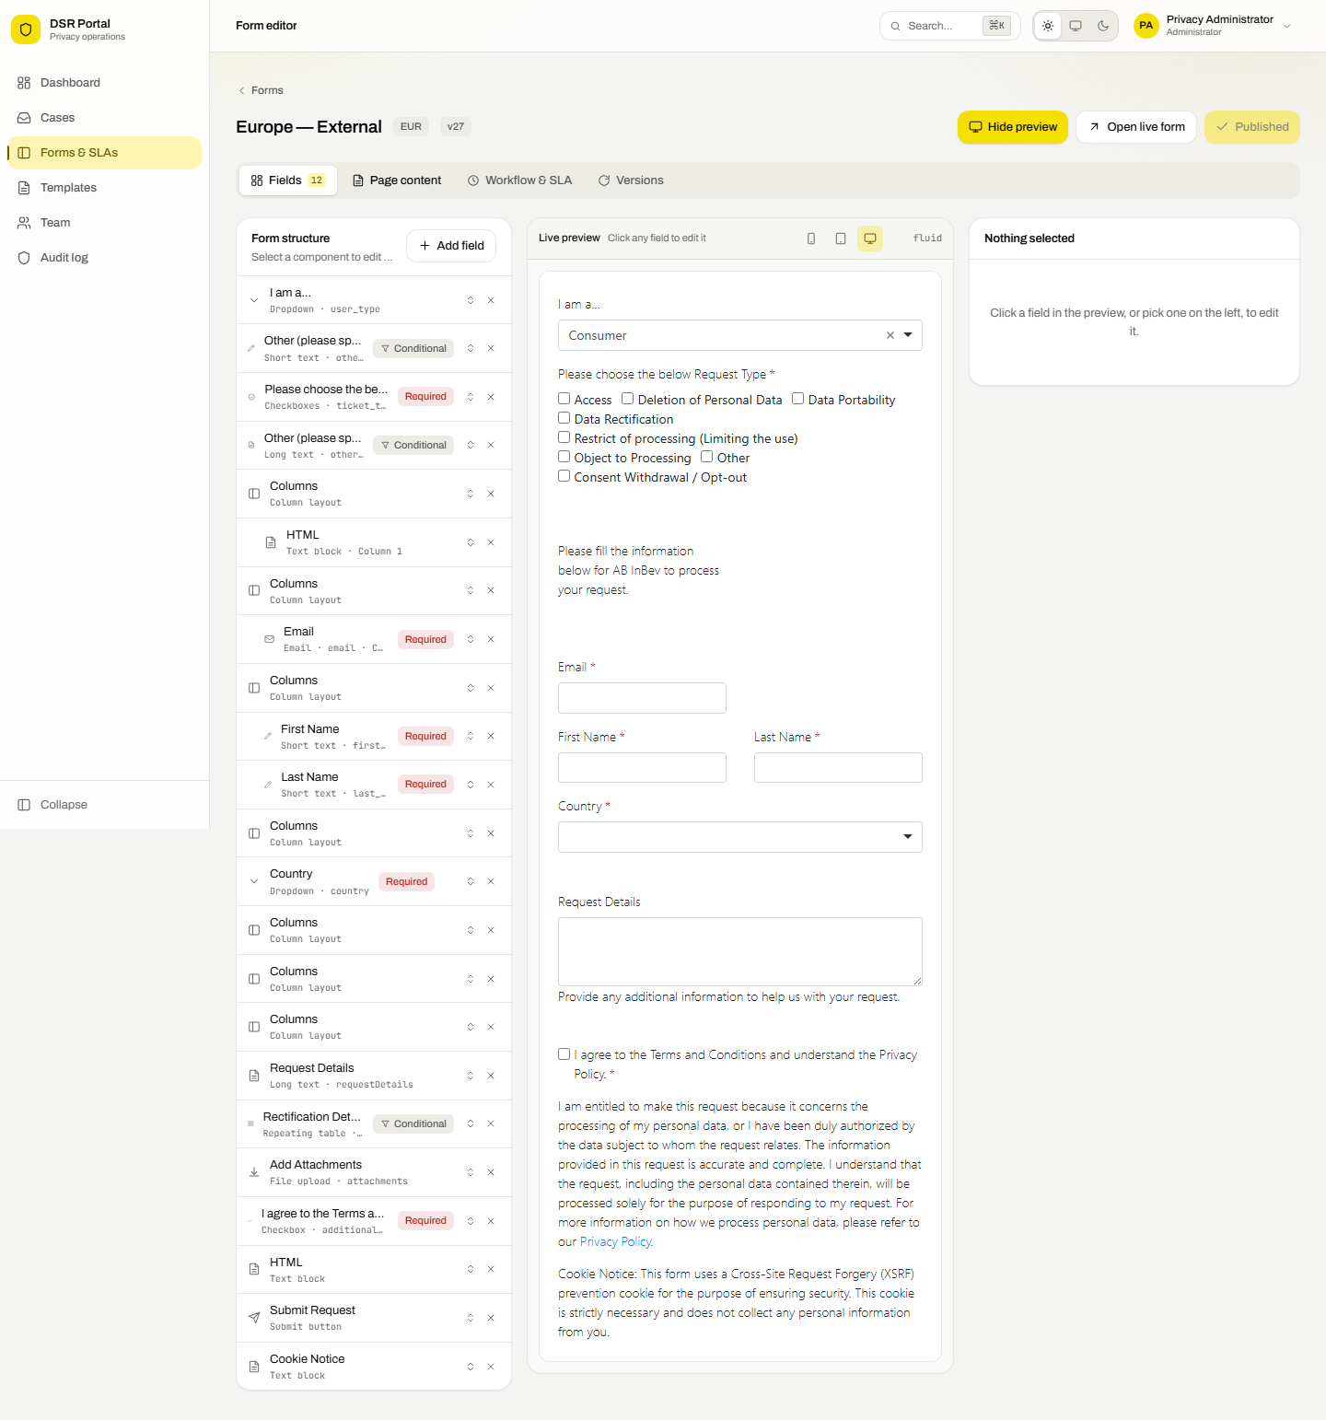
Figure 11 — the form structure
The left column is the form exactly as requesters meet it, top to bottom. Badges mark required fields and fields that only appear conditionally.
- Click a component to load its settings on the right.
- Use the arrows on a row to move it up or down.
- Use the cross to remove it. You are asked to confirm.
- Use Add field to insert a new one above the submit button.
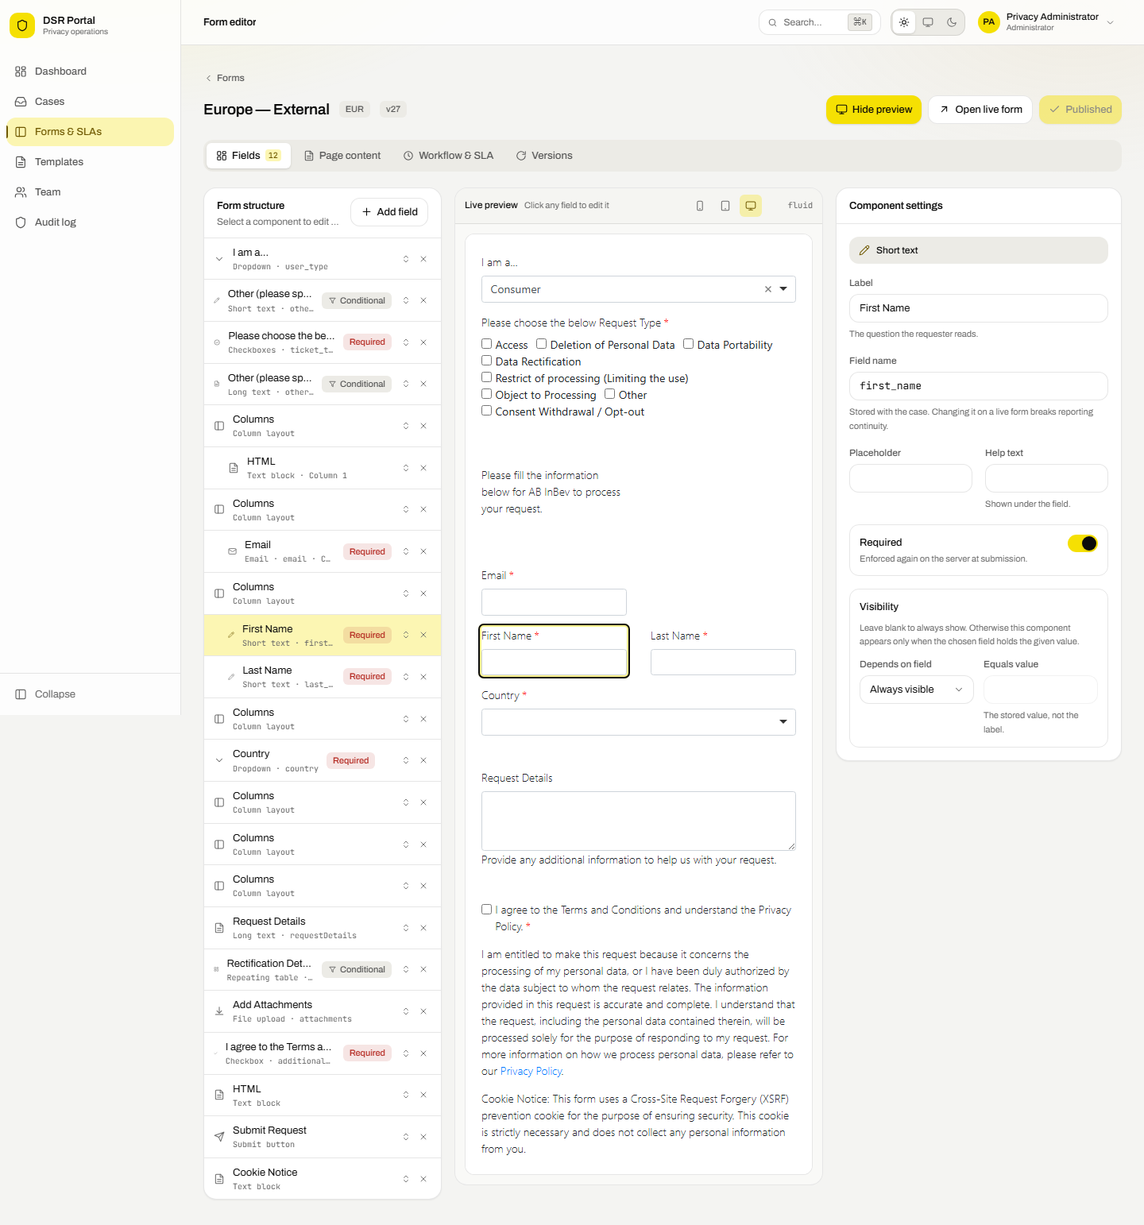
Figure 12 — editing a selected field
Setting | What it controls
Label | The question the requester reads.
Field name | The identifier stored with the case. Changing it on a live form breaks continuity with existing reports.
Placeholder | Grey hint text inside the box.
Help text | A line of guidance under the field.
Required | Whether the form can be submitted without it. Enforced again on the server.
Options | For dropdowns, checkboxes and radio buttons: the label the requester sees and the value stored.
Visibility | Show this component only when another field holds a given value.

Adding a field
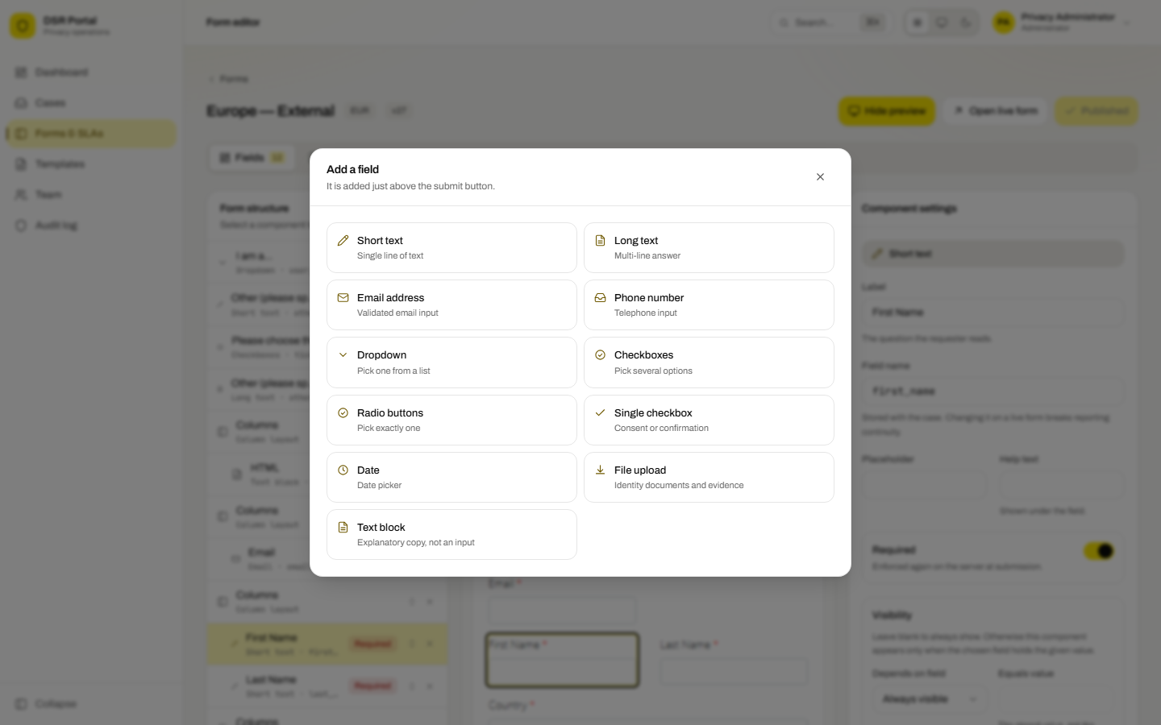
Figure 13 — the field palette
Eleven field types are available, from short text and dropdowns through to date pickers, file uploads and explanatory text blocks.

7.3 Editing the wording
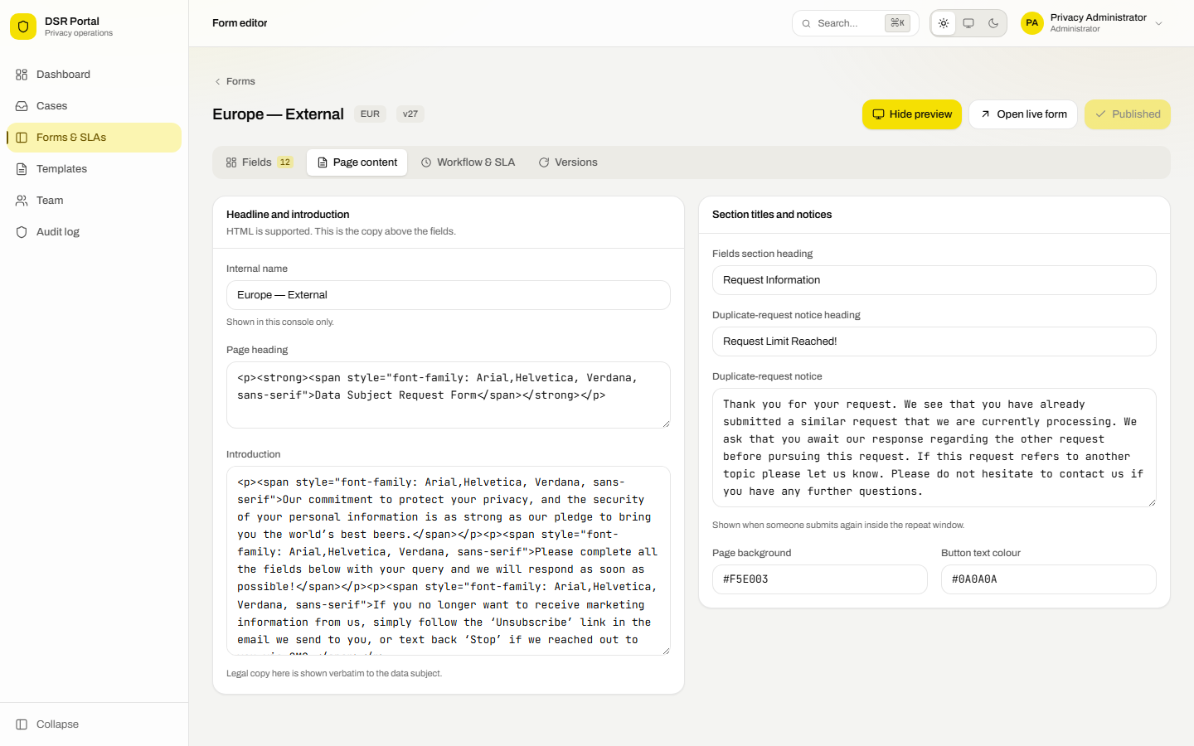
Figure 14 — page content
Change the heading, the introduction, the section titles and the duplicate-request notice. HTML is supported, so links and emphasis work as expected.
Warning Introduction copy usually contains legally reviewed statements about identity, consent and retention. Do not paraphrase it without Legal's approval.

7.4 Workflow and deadlines for a form
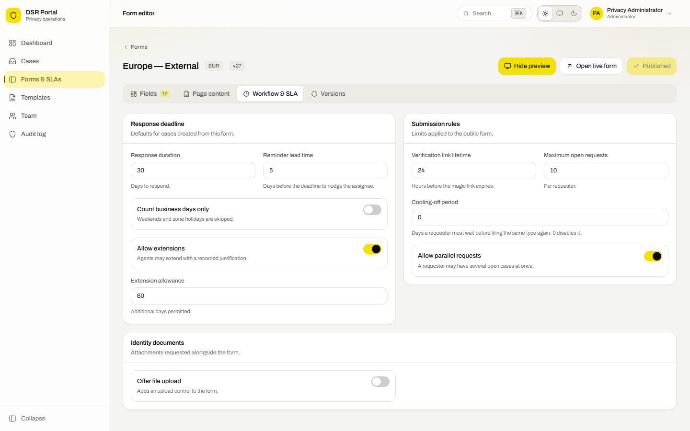
Figure 15 — workflow and SLA settings
Setting | Effect
Response duration | Days allowed to respond to requests from this form.
Reminder lead time | How many days before the deadline the assignee is nudged.
Count business days only | Skips weekends and the zone's public holidays.
Allow extensions | Whether agents may extend, and by how many days.
Verification link lifetime | How long the emailed magic link stays valid.
Maximum open requests | How many open cases one requester may have.
Cooling-off period | Days a requester must wait before filing the same type again.
Allow parallel requests | Whether one requester may have several cases open at once.
Offer file upload | Adds an upload control, optionally mandatory, with your own instructions.

7.5 Publishing and rolling back
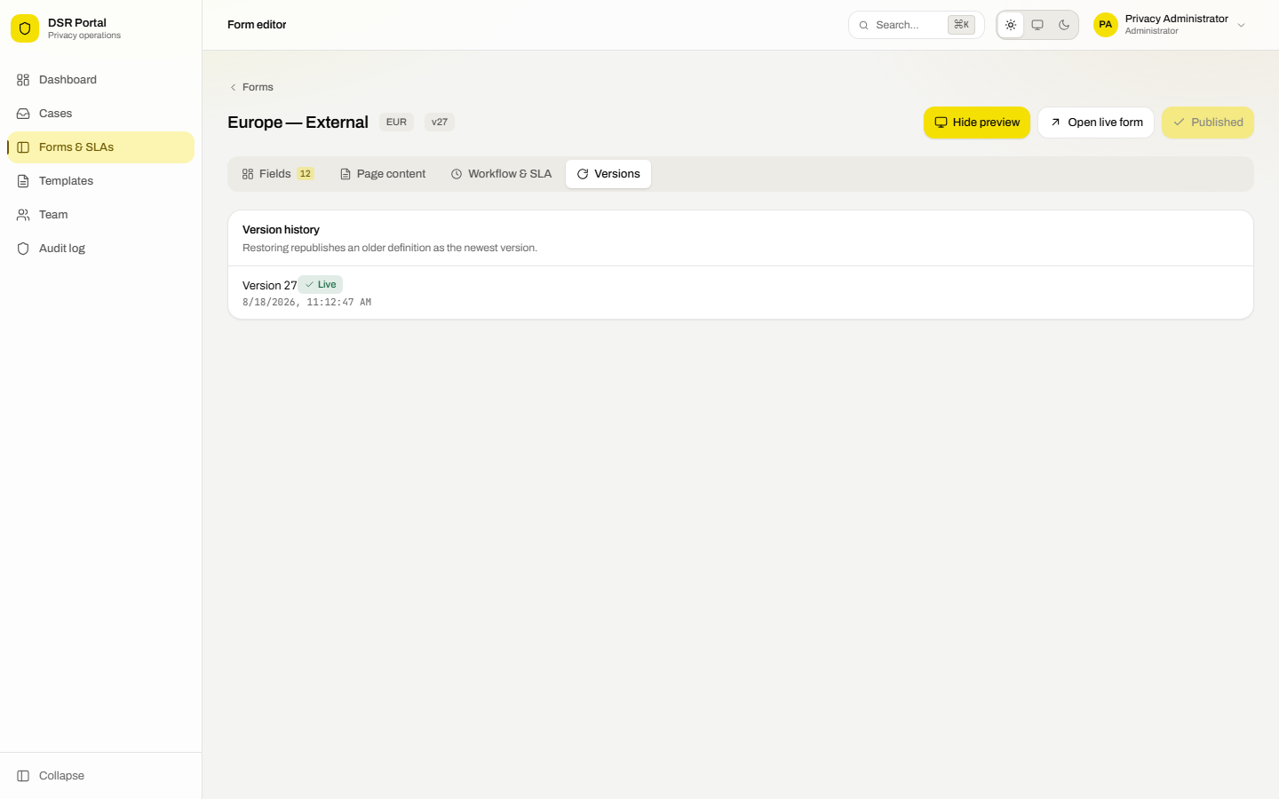
Figure 16 — version history
- Make your changes. An Unpublished changes badge appears.
- Press Preview to open the live public form in a new tab and sanity-check it.
- Press Publish changes. The portal validates the form and refuses anything broken, listing each problem.
- The new version goes live immediately.
Tip Publishing never rewrites history. Cases already submitted keep rendering against the version they were filed under, so an old case always shows exactly what its requester saw.

To undo, open **Versions** and press **Restore** on an earlier one. That republishes it as the newest version, so the trail stays complete.

7.6 SLA policies
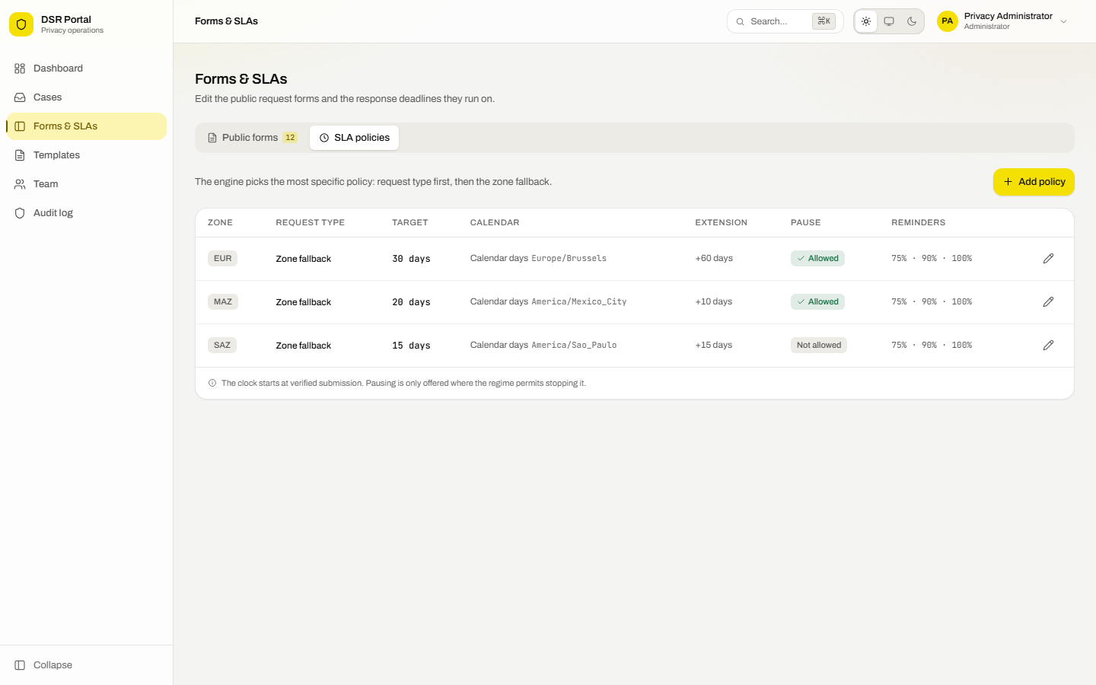
Figure 17 — the SLA matrix
SLA policies are set per zone and per request type. The engine always picks the most specific match: the request type first, then the zone fallback.
Setting | Effect
Response deadline | Statutory days to respond.
Extension allowance | Extra days an agent may add. Zero forbids extensions entirely.
Timezone | Used when counting business days.
Count business days only | Skips weekends and the listed holidays.
Allow pausing the clock | Only enable where the regime permits stopping the clock.
Reminder points | Percentages of the deadline at which the assignee is reminded, for example 75, 90, 100.
Public holidays | ISO dates skipped when counting business days.

Important The shipped values are placeholders: EUR 30 days, SAZ 15 days, MAZ 20 days. Confirm the real figure for every zone and request type with Legal before go-live.

8. Team and assignment
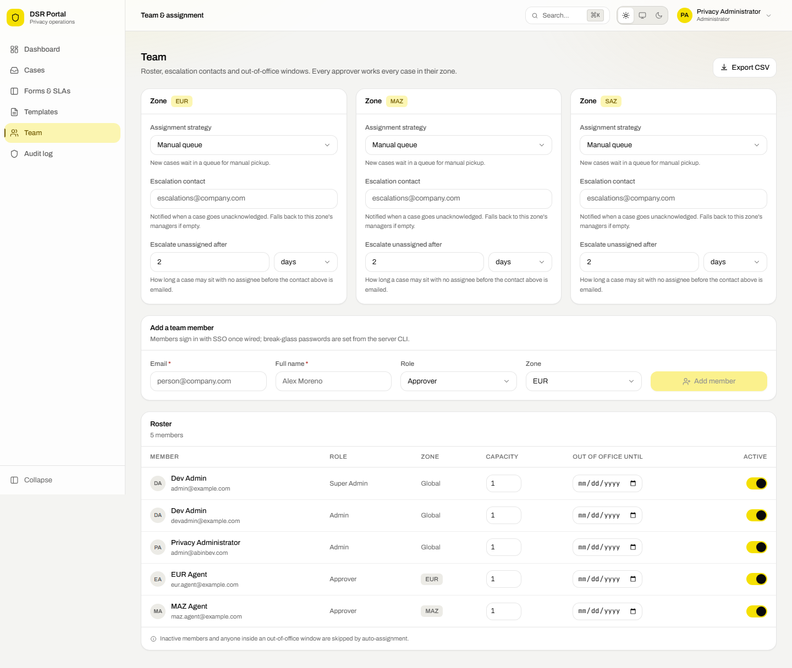
Figure 18 — team and routing

8.1 How cases are routed
Strategy | Behaviour
Round robin | Rotates evenly through available members. The default.
Least open cases | Gives the case to whoever has the smallest open workload.
Weighted | Balances by capacity weight, for part-time or partly allocated staff.
Manual queue | Nothing is auto-assigned; cases wait to be picked up.

Anyone inactive, or inside an out-of-office window, is skipped automatically. If a zone has nobody available the case stays unassigned and a warning is logged, so it is never silently lost.

8.2 Managing people
- Fill in email, name, role and zone, then press Add member.
- Adjust Capacity to weight how much work someone receives.
- Set Out of office until to take someone out of rotation; clear the date to bring them back.
- Switch Active off when someone leaves. Their history stays intact.
Note New members sign in through your identity provider once it is connected. Break-glass passwords are set only from the server command line, never through this screen.

9. Audit log
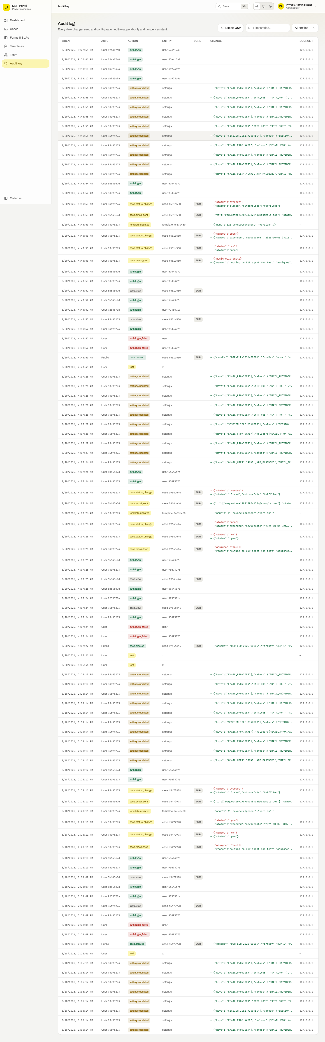
Figure 19 — the audit trail
Every view, edit, status change, email, form publication and configuration change is recorded with who did it, when, from which address, and what changed.
- The log is append-only: the database itself refuses updates and deletions, even from its owner.
- Secret values such as passwords and API keys are recorded as redacted, never in the clear.
- Filter by entity type, or search the text of any entry.
- Only administrators, super administrators and auditors can read it.

10. Settings
Note Settings is restricted to super administrators.

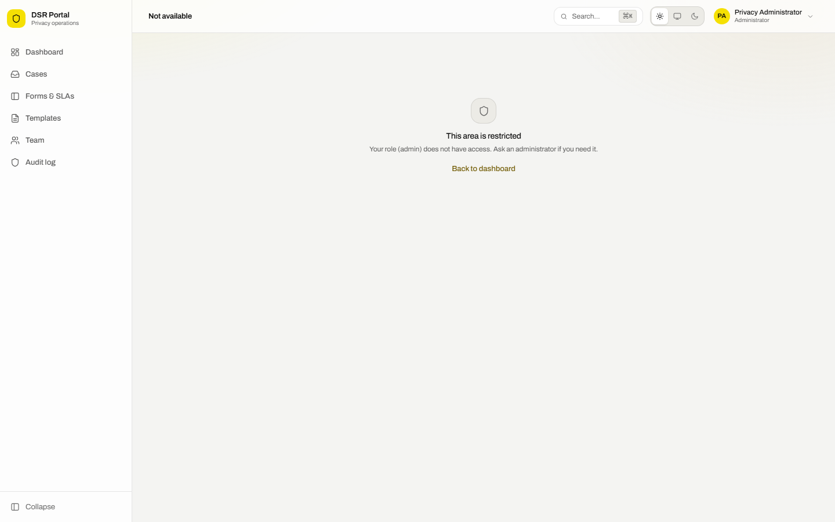
Figure 20 — the Settings screen
Everything that used to be an environment variable is edited here and takes effect immediately, with no restart.

10.1 How values resolve
- A value saved here always wins.
- Otherwise the server's environment value applies.
- Otherwise a built-in default applies.
Each field shows which of the three it is currently using. Clearing a field and saving removes the stored value so the environment applies again.
Tip Secrets are encrypted before storage and are never sent back to the browser. The screen only shows whether one is set.

10.2 Email delivery
Provider | When to use it
Gmail, app password | Gmail sending over SMTP. Needs 2-Step Verification and a 16-character app password. Not usable on this server, whose host blocks outbound SMTP.
Gmail, OAuth2 | Gmail sending over HTTPS. Works where outbound SMTP is blocked.
Microsoft Graph | Sends from a shared mailbox in Microsoft 365. Over HTTPS.
Resend | An email API over HTTPS. The quickest option where SMTP is blocked.
Custom SMTP | Any other mail server: host, port, encryption, username and password.
Console | Development only. Writes messages to the log instead of sending.

10.3 Checking email works
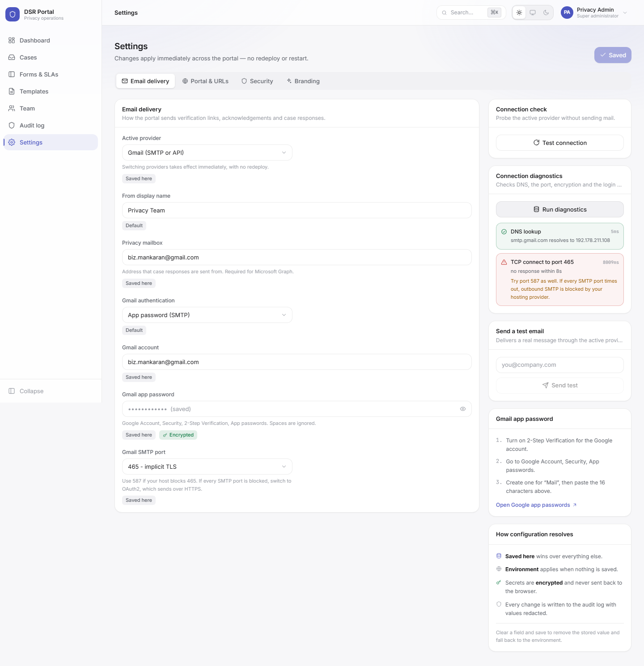
Figure 21 — connection diagnostics
Two tools sit in the right-hand column:
- Test connection signs in to the provider without sending anything.
- Run diagnostics checks each layer in turn — name lookup, the port, encryption, then the login — and names the layer that failed with what to do about it.
- Send test delivers a real message to an address you choose.
Warning This server's hosting provider blocks the standard outbound SMTP ports, 25, 465 and 587. Diagnostics will show the port check failing for Gmail and for any relay on those ports. Use one of the working paths in 10.4 instead.

10.4 Sending email from this server
Four routes work from this host. Three send over HTTPS and need no SMTP at all; the fourth uses a relay on port 2525, which is open here.
Route | How to set it up
Gmail over OAuth2 | Connect a Google account from the Settings screen. See 10.5.
Resend | Set the provider to Resend and paste an API key. Sends over HTTPS.
Microsoft Graph | Set the provider to Microsoft Graph, fill in the tenant, client ID and secret, and set the privacy mailbox.
A relay on port 2525 | Choose Custom SMTP and press a relay preset. See 10.6.

Note Port 2525 is the only SMTP port reachable from this server. If a relay is configured on 587 it will time out; change the port to 2525 and it will connect.

10.5 Connecting a Google account
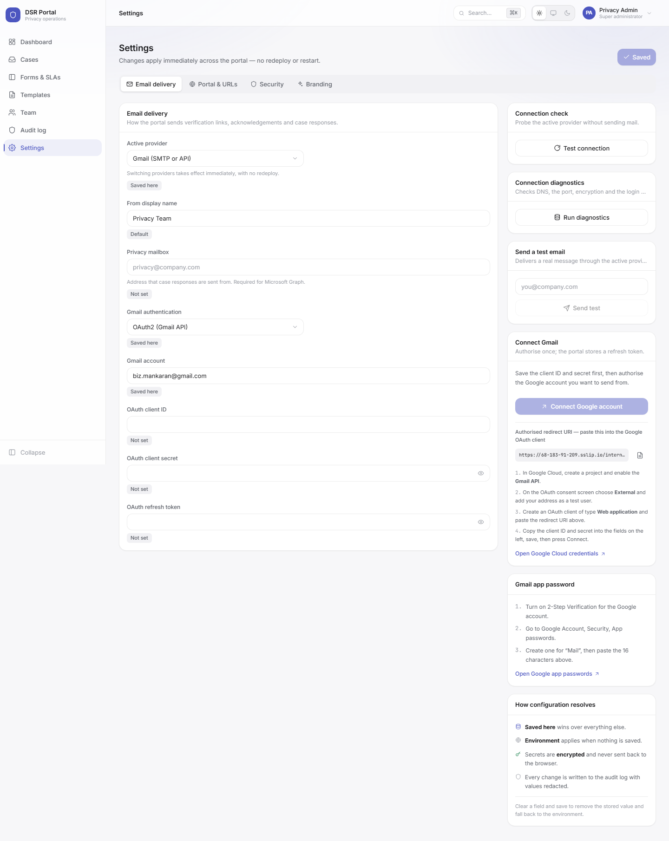
Figure 22 — the Connect Gmail panel
This authorises the portal to send as a Gmail account over HTTPS, which works even though SMTP is blocked. It is a one-time setup.
- In Google Cloud, create a project and enable the Gmail API.
- On the OAuth consent screen choose External and add the sending address as a test user.
- Create an OAuth client of type Web application and paste in the redirect URI shown on the Settings screen. Copy it with the button next to it so it matches exactly.
- Back in Settings, set the provider to Gmail and Gmail authentication to OAuth2, paste the client ID and secret, and press Save.
- Press Connect Google account, sign in as the sending address and approve the request.
The portal stores a refresh token and fills in the Gmail address for you. Press **Send test** afterwards to confirm a real message arrives.
Tip The refresh token is encrypted like every other secret and is never shown back to the browser. To disconnect, clear the refresh token field and save.

10.6 Using a mail relay
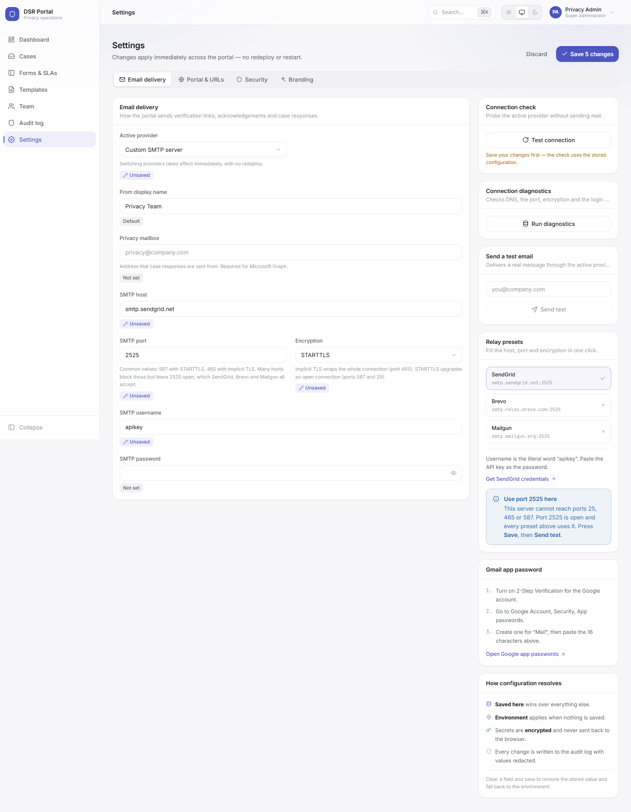
Figure 23 — relay presets for the Custom SMTP provider
A relay is a mail service that accepts your messages and delivers them onward. Set the provider to **Custom SMTP** and a panel of presets appears on the right. Pressing one fills the host, the port and the encryption for you, so only the username and password are left to enter.
Relay | Username to use | Password to use
SendGrid | The literal word apikey, filled in for you | The API key
Brevo | The login shown on Brevo's SMTP page, not your account email | The SMTP key
Mailgun | postmaster@your-domain, from the domain's SMTP credentials | That credential's password

- Create an account with one of the three and verify a sending domain.
- Generate an API key or SMTP credential.
- In Settings choose Custom SMTP, press the matching preset, and paste the username and password.
- Set the privacy mailbox to an address on the verified domain.
- Press Save, then Send test.
Important Messages sent from an unverified domain are rejected by the relay or land in spam. Verify the domain first; every relay walks you through the DNS records.

10.7 Other settings
Group | Contains
Portal and URLs | The public and internal addresses used in emails and magic links.
Security | CAPTCHA keys, session idle and absolute lifetimes, and the sign-in and verification rate limits.
Branding | Organisation name and the reply-to address shown to requesters.

11. Quick reference

11.1 Keyboard shortcuts
Keys | Action
Ctrl+K or Cmd+K | Open the command palette
Up and Down | Move through palette results
Enter | Open the highlighted result
Esc | Close the palette or any dialog

11.2 Common questions

A requester says they never received the verification email.
- Ask them to check the spam folder; the message comes from the privacy mailbox.
- Links expire after 15 minutes. Ask them to press Verify email again.
- Only three verification emails per address per hour are sent. Ask them to wait if they have tried repeatedly.
- If nobody is receiving email, a super administrator should run Run diagnostics in Settings.

A case is overdue but we are waiting on the requester.
Where the zone's policy allows it, pause the SLA clock from the case screen. Where it does not, the clock keeps running: that is a legal constraint, not a limitation of the portal.

We need to add a question to a form.
Open **Forms & SLAs**, choose the form, press **Add field**, configure it and publish. The public form updates immediately, and existing cases are unaffected.

Someone left the team.
Switch them to inactive on the **Team** screen. Auto-assignment skips them straight away, and their case history stays intact for the audit trail.

11.3 Appearance
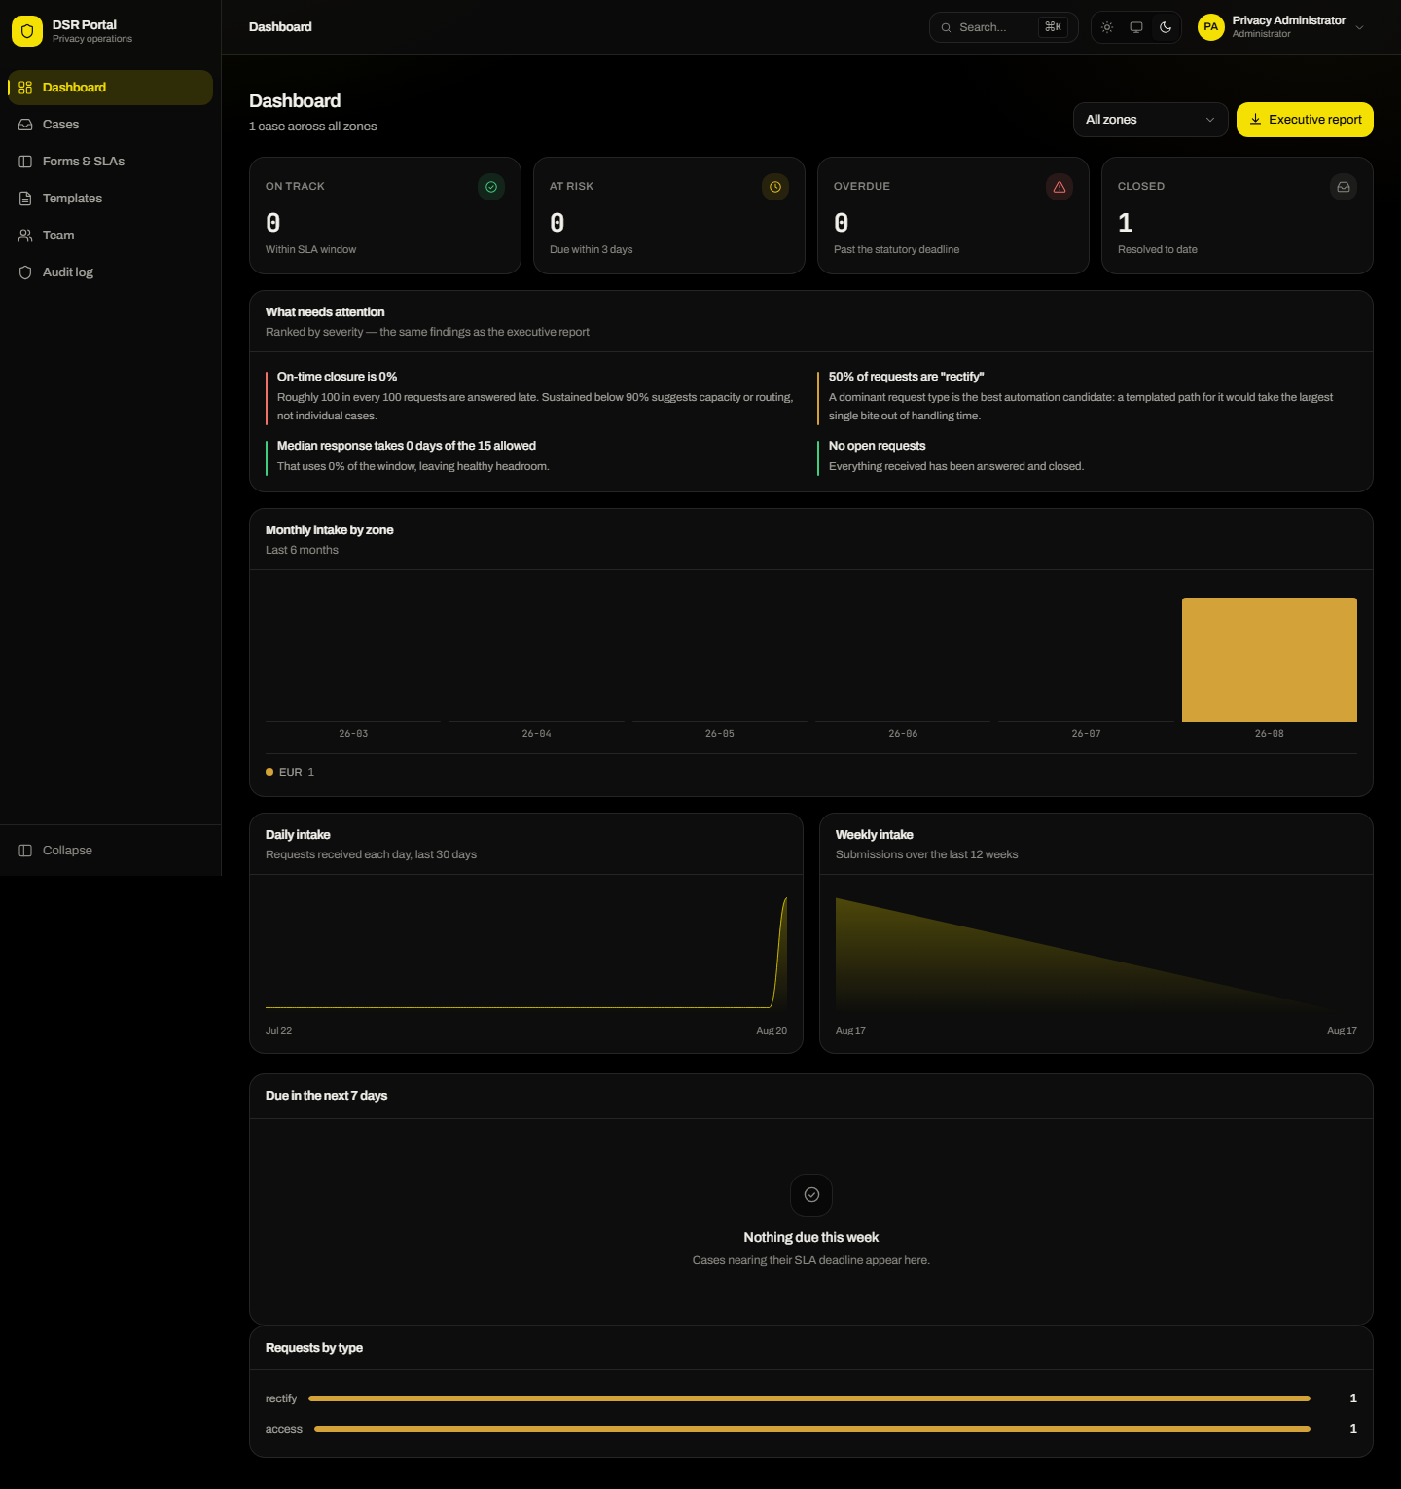
Figure 24 — the dashboard in dark appearance
The console supports light and dark appearance, and can follow your operating system. The choice is per person and remembered on the device.

